**How to JOIN (or LEAVE) an Outlook Distribution Group**

1. Go to: <https://vaww.myprofile.portal.va.gov/IdentityManagement/aspx/groups/AllDLs.aspx>
2. Search for the group you wish to join. For example, “***VHA NATIONAL AUDIOLOGIST***”
3. Check the box to the left of the list name
4. Select “**JOIN**” or “LEAVE”

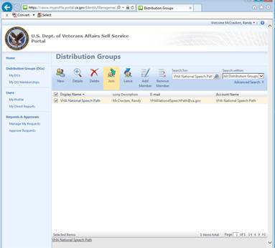

5. Click Submit

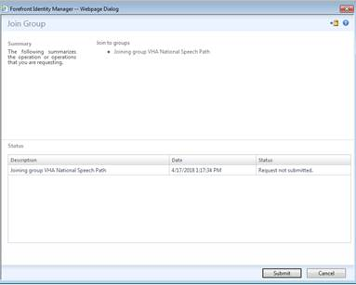

1. Click “OK”

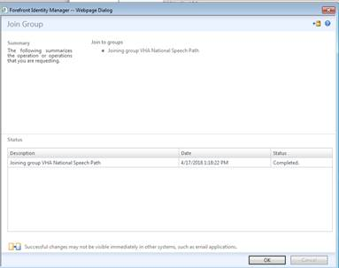

1. You have now successfully JOINED (**or LEFT**) the Outlook Distribution Group.