2016 Election Results!
President Elect: Hope Gillison, Au.D.
Member-at-Large: Erica Dombrowsky, Au.D.

Thank you to everyone who was able to meet us in St. Louis and made the “2015 JDVAC Conference: Ahead of the Curve” a huge success. We had great attendance, with amazing speakers, and even Lil’ Wayne showed up. On Monday evening, the AVAA honored Dr. Lucille Beck for her dedication to audiologists across the discipline as a whole not only serving the MAA and AVAA. See page 3 for more details. It was a very special time and Dr. Beck will be missed, but we know she will make her place in history as the VA Deputy Chief Patient Care Service Officer of Rehab and Prosthetics Services.

Many contributed to the success of JDVAC and are deserving of thanks. First and foremost our exhibitors. Without your continued financial and educational support of this event, JDVAC would not be as successful. Your support and commitment allows attendees opportunities to stay current in our field.

A very big thank you to VACO for their continued support of JDVAC. Thank you for continued guidance and support to make each JDVAC better each year.

JDVAC would not be possible without the hard work and dedication of our volunteers. Our volunteers put in countless hours for their subcommittee and the educational committee to bring each year a better JDVAC. They work behind the scenes without recognition. I thank you for making us, the chairs, look so good! You are rock stars!
Program Chairs: Sean McClenney and Maj Brandon Tourtillott

Education Committee: R. Hope Gillison, Chair; Danielle Harper, Co-Chair

Presentations: Sean McClenney and Maj. Brandon Tourtillott, Chair: Maureen Wargo
Field Presentations: Lynn Henselman, Chair; LT Kyle Shepard Co-Chair; LT Amy McArthur, Jennifer Barnes, COL Marjorie Grantham, LT Amanda Boudreaux, Julie Gardner, Vivianne Wersel, Nanette Lee, Nannette Gwinner

Poster Session: Karen Sugiura, Chair; Jana VeraSforzza, Co-Chair; Dawn Martin, Robert Folmer, Owen Murnane, Kim Schairer, Curtis Billings, Margaret Peak, Richard Folino, Sherri Smith, Earl Johnson, Marjorie Grantham, Michael Murphy, Amanda Baum, Shantel Dever, Kathleen Conley, Holly Burrows

Printed Program: Aneda Baker, Chair; Yunea Park, Co-Chair

Exhibitors: MAJ Jillyen Curry-Mathis, Chair; Maj Shannon Hunt, Co-Chair; Heather Neudecker, Christa Johnson, Elizabeth Phelan

Registration/App: Melissa Johnston, Chair, Vincenza Damico, Co-Chair

Continuing Education Units: Mary Kelly Bone, Chair; Kate Conroy, Co-Chair

Concha Bowl: Rose White, Chair; Angela Pond, Co-Chair; Angela Higdon, Lori Howe, Larissa Jurtshuk,

Student Experience: Erica Dombrowsky, Chair; Eddie Abalos, Co-Chair; Julie Miles


JDVAC 2016: Ahead of the Curve
This newsletter was prepared on behalf of the Association of VA Audiologists and does not reflect the view of the Department of Veterans Affairs.

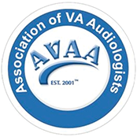

June 2016
Issue 2
AVAA NEWS
Innovation/System Re-design Group or Individual Award: Darrin Worthington
Dr. Darrin Worthington is the TeleAudiology Clinical Champion at the Lovell Federal Health Care Center (FHCC) in North Chicago, IL. He has been a leader in systems redesign having been part of multiple process improvement projects and has played a significant role in the development and rollout of teleaudiology services throughout the VA. In all of his work, Dr. Worthington reflects that best of Veteran-centered care and its inherent values. He is innovative but remains solidly grounded in the reality of everyday practice and its many challenges.

Customer Service Award: Oscar Armero, Au.D.
Dr. Armero is Section Chief of Audiology at the James A. Haley VA Hospital, Polytrauma Rehabilitation Center in Tampa, Florida. His unique vision and unwavering commitment has culminated in the development of the Audiology Care Team (ACT) which is an evidenced based process designed to provide a high level assessment, hearing rehabilitation, co-morbid identification and referral services to elderly veterans utilizing a team of trained professionals and focused resources. Dr. Armero is committed to education and has mentored nearly 100 audiology clinicians and physicians and given 15 regional and national presentations along with 6 published articles.

Research or Education Award: TIE: Curtis Billings and Marjorie Leek
Curtis Billings
Dr. Curtis Billings is an expert in the field of auditory neuroscience, often with an encyclopedic knowledge of the latest research developments yet he seemingly effortlessly impacts the lives of people around him and instills a passion for the pursuit of research. Dr. Billings has a natural talent for seeing and tapping into the best qualities of the people around him, even as he maintains a thoughtful and objective eye towards each individual’s strengths and limitations.

Marjorie R. Leek, Ph.D.
Dr. Marjorie R. Leek has served for 35+ years in the field of auditory research and education for Veterans Health Administration (VHA), Department of Defense (DOD), and several education institutions and is currently serving within Loma Linda VA Healthcare System as a Senior Research Scientist and is also a research professor for the Departments of Otolaryngology-Head and Neck Surgery at Loma Linda University and at Oregon Health & Science University. Dr. Leek’s primary research is aimed at understanding the nature of the communication and perceptual difficulties that accompany sensorineural hearing loss and the consequences of impaired cochlear processing in Veterans and non-Veterans with hearing loss.

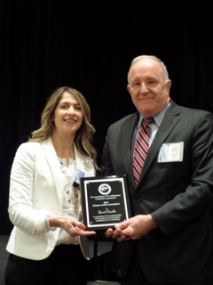

Honors of the Association: David Chandler, Ph.D
Dr. David Chandler is the Deputy Chief Consultant for Rehabilitation and Prosthetics Services for the Department of Veterans Affairs. Dr. Chandler received his Master’s degree from FSU and went on to earn a PhD in Hearing Science from Vanderbilt University. Dr. Chandler has worked for the Department of Veterans Affairs since 2007 following a distinguished career in the Army from which he retired after 30 years at the rank of Colonel. Dr. Chandler has been one of VA Audiology’s biggest advocates in Washington as a champion for many field-related issues such as Choice, the audiology workstation project, catastrophic disability regulations for hearing loss, and many other past and current issues that have come up during his almost 10 year commitment to VA. His service to his Country, the VA and the profession is truly deserving of this recognition and this award.

Lieutenant Frank B. Walkup IV Distinguished Service Award: Scott Forbes
Dr. Scott Forbes received multiple nominations for this award. He is a combat Veteran of the United States Marine Corps, with service medals earned for exemplary performance and leadership as Commanding Officer, and for professional achievement as an Audiologist and Hearing Conservation Officer. He currently works at the Michael E. DeBakey VA Medical Center in Houston, Texas. He also serves in the Army Reserve as an Audiology and Preventive Medicine Staff Officer to the Army Surgeon General, where he supports the development and implementation of the audiology program and hearing conservation policy for the Army, the Army Reserve and the Army National Guard. He has also been a great asset in assisting VA audiologist with access to the DOEHRS program.
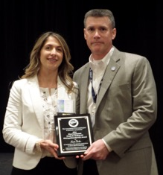

AVAA Award Winners 2016

Page 2

AVAA News

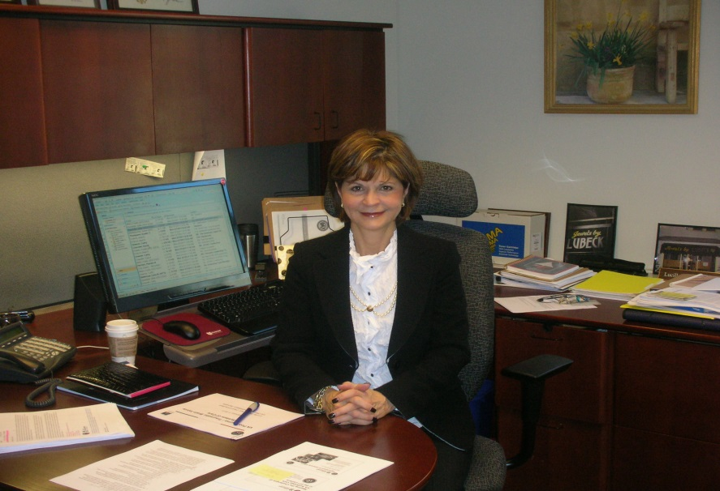
Dr. Beck was introduced to the VA, like many of us, as a doctoral student and began her VA career as a clinical audiologist. She became the Coordinator of VA’s National Hearing Aid Program at the same time she also became the Chief of the Audiology and Speech Pathology Service at Washington, D.C. VA Medical Center. In 1996 she was named the National Director for Audiology and Speech Pathology Service while continuing to lead audiology and speech pathology at the DC VA. 2002 she became Chief Consultant for rehabilitation services and prosthetics was also rolled under her leadership. In 2014, she was appointed the Deputy Patient Care Services Officer for rehabilitation and prosthetic services and today she is wearing more hats than any one person should wear and doing a magnificent job of leading in the VA.
Dr. Beck has made innumerable contributions to the profession on all levels. She has held faculty appointments at several universities, teaching graduate courses in Audiology and provided clinical training for students. She has authored and co-authored numerous publications, scientific papers, and is a well-known presenter on topics ranging from amplification, outcomes, patient satisfaction and professional issues in Audiology. She is a founding member and past president of the American Academy of Audiology. Dr. Beck was integral in the creation of the clinical doctoral degree (Au.D) in Audiology. For over a decade she was the voice of audiology representing individuals with hearing loss as an FDA panel member and fought for the safety and efficacy of cochlear implants – a role that had her going head to head with surgeons and the industry. Her contributions have been recognized by awards both from all audiology professional associations as well as many from VA.
Her vision included ordering hearing aids through ROES and she facilitated a relationship with DALC who became our partners in the mission of providing hearing healthcare to our Veterans. Given the success of the hearing aid contracts, the idea was born to create an assistive listening device contract and a cochlear implant contract.
Her strong knowledge of hearing aid technology assisted not only with contracting but was integral in getting the funding and staff for the large hearing aid controlled trial published in JAMA, which was groundbreaking research. She’s been a proponent for mentoring and has always been a strong advocate for a team based approach to care, feeling that health technicians were an integral part of the audiology team. She pushed the Field Advisory Council for a National Outcome measure to provide data supporting VA hearing aid program and she saw an opportunity with telehealth 6 years ago and today audiology is one of the largest specialty providers of virtual care.

Dr. Beck championed Audiology and Speech Pathology’s transition to Title Hybrid 38 for over 20 years to improve hiring practices and promotion opportunities benefiting all VA Audiologists. In the late 90s she saw the need for an employee organization and supported the development of AVAA. Several years later she encouraged the multi-day independent meeting we all now call JDVAC.

One outstanding accomplishment of Dr. Beck’s often cited is her handling of eligibility reform in 1996 when new laws and regulations were passed allowing entry into the VA for many more Veterans. As a new National Director, Dr. Beck had a choice on how to lead our profession. Believing that noise-induced hearing loss was an occupational injury related to military service, she felt comprehensive hearing services, including hearing aids should be provided. Had she led a different way, many of you wouldn’t be reading this as her leadership during eligibility reform created many more jobs for VA audiologists

VA Audiology has been at the forefront for excellence and evidence-based practice because of Dr. Beck’s leadership. We are where we are today is based on years of hard work, long days, negotiations, strategies, and the ability to build relationships both inside and outside the VA. She’s a critical thinker, she sees the big picture and very strategically plans a path, talks to the right people, resulting in very positive outcomes. She has been a leader, not a manager and her vision for VA audiology and for us, the future of VA audiology, is truly inspirational.

A Salute to Dr. Beck

Page 3
AVAA News

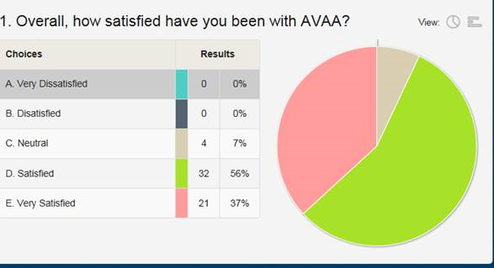
Stay in touch with AVAA There have been many regulatory and legislative changes and challenges in the past year. To stay abreast of current AVAA updates go to: http://myavaa.org/ and register with a non-VA email address. JDVAC 2016 Memories 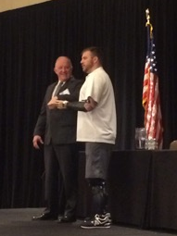 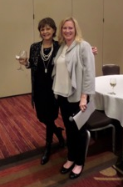 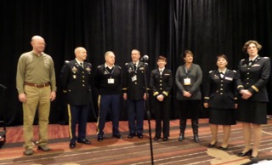
Save the Date!

JDVAC 2017
February 6-8, 2017
Anaheim, California
We asked, you answered!
Thank you to everyone who responded to the AVAA membership survey both at JDVAC and via survey monkey. While we were pleased that our membership is generally satisfied, we know there is still work to be done. Look for initiatives based on your responses and suggestions in the future!

Page 4

AVAA News

